Resume

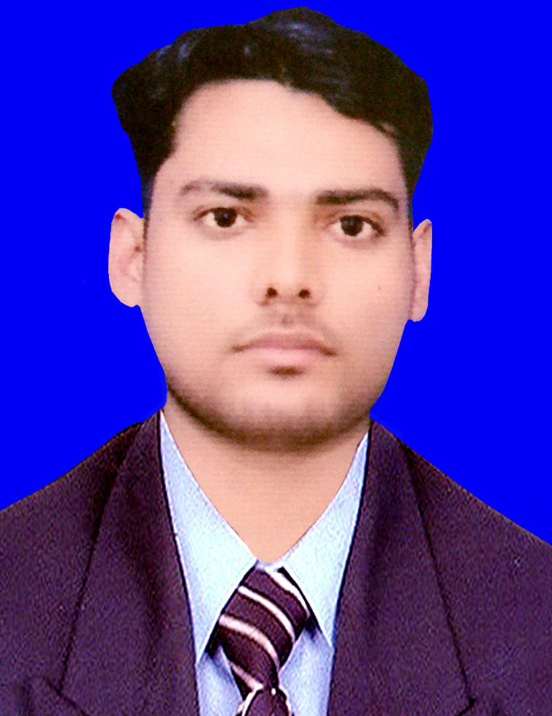
Rishabh Upadhyay
Kanpur (Uttar Pradesh)
Cell :+91 8317020955
Email: rishabhoet2d@gmail.com

Career Objective
- To make positive contribution as part of any organization in a position where my management, decision making and communication skills well be appreciated and enhanced

Course Details
Degree: | Pursuiung MBA | Specialization: | Marketing and Operations

Educational Details
Qualification | Institute | University/Board | Year of Passing | %
Graduation | SJ Mahavidyalaya, Ramaipur, Kanpur | CSJM University | 2018 | 56
XII | Paritosh Inter College | (UP Board) | 2014 | 77.2
X | City Education Centre | (UP. Board) | 2012 | 78.33

Computer Skills
: Basic knowledge about Internet and Computer .
: Basic knowledge about useful Software Office,Paint,Photoshop,Tally.
: 18 month computer course of ADCSIM

S Strengths
- Self Confidence, Positive Attitude

- Positive Attitude,
- Good Communication Skill,
- Team Work Skill
- Effective Time Management

Experience
- Worked in Trendy Today E-commerce PVT Solution as a Operational Executive from Jan 2016 to mar 2017
- Worked in Trendy Trendy Today E-commerce PVT Solution as a Business Development Executive from April 2017 to Mar 2018

Hobbies
- Listening to Music
- Watching movies/TV

Personal Details
Fathers Name : Mr. Manoj Upadhyay
Date of Birth : 23-09-1998
Nationality : Indian

Gender : Male

Marital Status : UnMarried
Languages Known : English & Hindi

Declaration

- I here by declare that all the particulars given above are true to the best of my knowledge and belief.

Place : Kanpur Signature
Date : Rishabh Upadhyay

